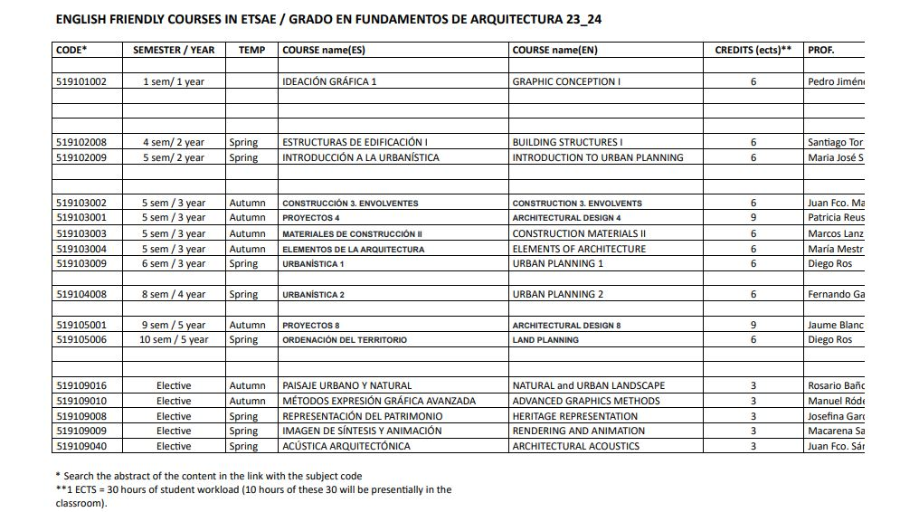

In order to see the abstract of the content of each subject (in English) you can visit this website:

[Grado en Fundamentos de Arquitectura | Plan de Estudios - Escuela Técnica Superior de Arquitectura y Edificación | UPCT](https://emea01.safelinks.protection.outlook.com/?url=https%3A%2F%2Fetsae.upct.es%2Fplan-de-estudios%2F5191&data=05%7C01%7C%7C369bb0ae39074e058ce308db3d0727e4%7C84df9e7fe9f640afb435aaaaaaaaaaaa%7C1%7C0%7C638170873184022645%7CUnknown%7CTWFpbGZsb3d8eyJWIjoiMC4wLjAwMDAiLCJQIjoiV2luMzIiLCJBTiI6Ik1haWwiLCJXVCI6Mn0%3D%7C3000%7C%7C%7C&sdata=9yEEqU3Vv6O%2BvAO%2B3SudsqHv4NnxyJfeVQPKmDKpi4w%3D&reserved=0)

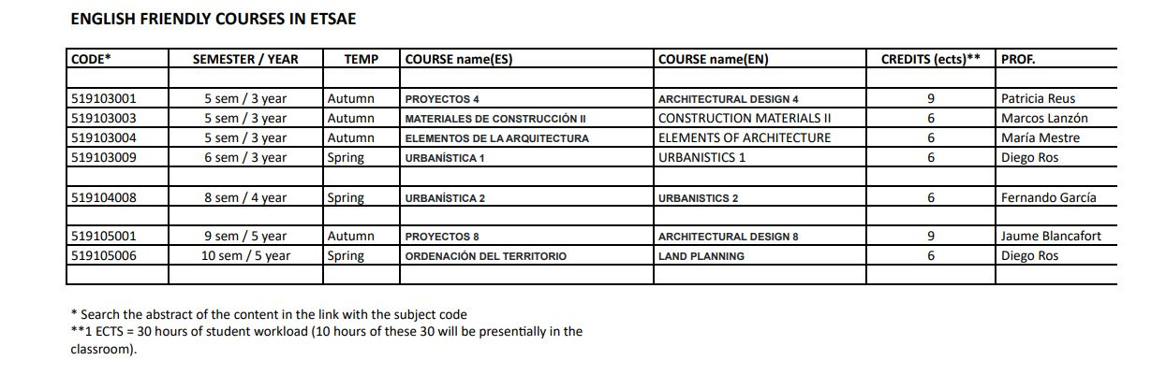

In order to see the abstract of the content of each subject (in English) you can visit this website:

[Grado en Fundamentos de Arquitectura | Plan de Estudios - Escuela Técnica Superior de Arquitectura y Edificación | UPCT](https://emea01.safelinks.protection.outlook.com/?url=https%3A%2F%2Fetsae.upct.es%2Fplan-de-estudios%2F5191&data=05%7C01%7C%7C369bb0ae39074e058ce308db3d0727e4%7C84df9e7fe9f640afb435aaaaaaaaaaaa%7C1%7C0%7C638170873184022645%7CUnknown%7CTWFpbGZsb3d8eyJWIjoiMC4wLjAwMDAiLCJQIjoiV2luMzIiLCJBTiI6Ik1haWwiLCJXVCI6Mn0%3D%7C3000%7C%7C%7C&sdata=9yEEqU3Vv6O%2BvAO%2B3SudsqHv4NnxyJfeVQPKmDKpi4w%3D&reserved=0)