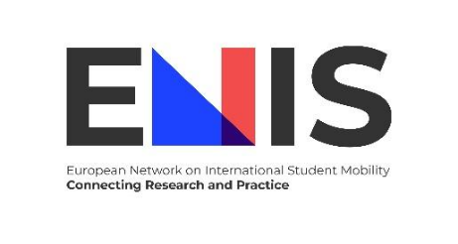

**3rd ENIS Training School for Young Innovators – developing effective policy briefs**

**Are you ready to make an impact?**

Following the success of our first two training schools, we are thrilled to announce the **third edition of the ENIS Training School for Young Innovators**! This time, the focus is on equipping young innovators with the skills to prepare **effective policy briefs** that link research to action and foster meaningful societal change.

***Who can participate?***

The training school is designed for:

* **PhD students** (in their second year or later)
* **Researchers and practitioners** (under 40 years old or within three years of completing their PhD)

***What skills will you gain?***

* Master the art of crafting impactful policy briefs that bridge research and policy.
* Enhance your ability to communicate research findings to policymakers and stakeholders effectively.
* Engage with experts and peers in a supportive, collaborative environment.

***Training Format***

The program includes **three sessions**:

1. **Session 1 (Online):** Introductory workshop to developing policy briefs
   * **Date:** 5 March 2025
   * **Time:** 11:00–12:30 CET
   * **Trainers:** Giorgio Marinoni (IAU), Cosmin Nada (ISCTE), Rúna Vigdís Guðmarsdóttir (Rannis) & Mete Sipahioglu (Samsun University)
2. **Session 2 (Hybrid):** Hands-on workshop and peer feedback. Trainers are
   * **Date:** Thursday, April 3, 2025
   * **Location:** Sakarya, Türkiye (with an online option available)
   * **Trainers:** Martin Bogdan (ACA), Sahizer Samuk (BI Norwegian Business School), Thais França (ISCTE), Burcu Koç (Sakarya University) & Christof Van Mol (Tilburg University)

1. **Session 3 (Online Follow-Up):** Personalized feedback by an ENIS member and finalizing your policy brief.
   * **Date and time:**to be established with your reader.

**Funding Opportunities**

* **15 grants** are available to support travel expenses (max 450 euros for transport and a daily allowance to cover accommodation) for the hybrid session in Sakarya.
* **Participation in**all**sessions**(including the hybrid session in Sakarya) **is free of charge.**
* **To qualify for travel funding, participants must attend all three sessions**.
* Self-funded participants are also welcome!
* Participation is open to anyone, ENIS membership is not a requirement

***How to apply***

Don’t miss this opportunity to advance your career and make your research matter! **Apply here before 27 February 2025:** <https://forms.gle/dTdnAE1koiRSHBpR9>